Eagle Scout Certificate

The Supreme Lodge Knights of Pythias would like to honor your Eagle Scout
with a certificate and patch.
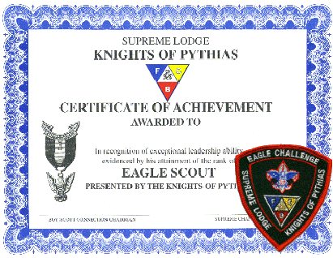

The Fraternal Order of Knights of Pythias is a partner of the Boy Scouts of America
Request an Eagle Scout Certificate & Patch

Please provide the information requested.
Top of Form
Your Name:
Your e-mail Address:
Your phone number (in case we cannot email you for questions):

Scout's name:
Scout's Postal Address (street, town, zip):
Scout's age (if known):
Scout's Troop number and location (i.e. 3 Yourtown, NY):
Scout's Troop Sponsor (i.e. Yourtown Fire Dept.):
Brief description of Scout's Eagle Service Project:

Name and address of party to whom we should mail the certificate:
Court of Honor Date:
Additional comments?
Bottom of Form
Please e-mail to: Michaelmhh6@verizon.net
Or Fax to: (866) 842-4098

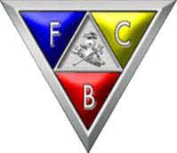

The Order of Knights of Pythias is a great international fraternity which was founded in Washington, DC, February 19, 1864, by Justus H. Rathbone, and embraces more than two thousand subordinate lodges in the United States and Canada, with occasional lodges having been formed elsewhere. The primary object of fraternal organizations is to promote friendship among men and to relieve suffering. Each organization adopts some outstanding principle as its objective. The individuality of an order is determined by its ideal sentiment. The distinguishing principles of the Order of Knights of Pythias are "FRIENDSHIP, CHARITY and BENEVOLENCE".
It bases its lessons and builds it ritual largely on the familiar story of the friendship of Damon and Pythias, who were historical characters living about four hundred or more years before the beginning of the Christian era. They were members of a school, founded by Pythagoras, who was known as the father of Greek philosophy.
To become a member of the Pythagorean Brotherhood, certain very rigorous tests were demanded and applied, some of which are very similar to the ritualistic work of our order today. The object of the organization was the moral uplifting and purification of society. Strict morality, absolute truthfulness, honor and integrity were thoroughly inculcated in the minds of its membership. It was a maxim of Pythagoras that the two most excellent things for man were "to speak the truth and to render benefits to each other" The outstanding feature of the society, however, was the marvelous friendship and loyalty which bound the brotherhood together with hoops of steel, which was so remarkably demonstrated in the incident which forms the historic basis of our order.
Damon had opposed the pretensions of the king of Syracuse, who had gained the throne by fraud, and as a result he was condemned to death. Pythias became a hostage for Damon, while the latter was permitted his liberty to bid his wife and child goodbye. Each was willing to die to save the other's life. Their loyalty to each other, the adventures that beset them, and the outcome of this noble friendship, form the basis for one of the most beautiful stories of history as exemplified in our ritual.

